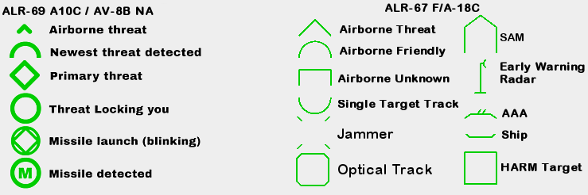
004 - Threat Database and RWR symbols

Ground Threats -- Altitudes rounded up to the next 100 ft.
RWR | Name | Range nmi |  |  | Altitude ft |  | Guidance  type | Ammo
RWR | Name | L. Alt.  Min | L. Alt.  Max | H. Alt.  Max | Min | Max | Guidance  type | Ammo
-- | ZU-23-2 | 0 | 1.1 |  | 0 | 6,700 | Op | 100
A | ZSU-23-4 | 0 | 1.1 |  | 0 | 6,700 | Rad | 2000
-- | ZSU-57-2 | 0 | 3.8 |  | 0 | 13,200 | Op | 254
2 | SA-2 | 3.8 | 21.6 | 16.2 | 328 | 82,100 | Rad-CMD | 1/Ln
3 | SA-3 | 1.9 | 5.9 | 13.5 | 656 | 59,100 | Rad-CMD | 4/Ln
5 | SA-5 | 15-20? | 40? | 138 | 1000? | too high | SARH
6 | SA-6 | 2.2 | 13.5 | 13.5 | 98 | 26,300 | Rad-CMD/SARH | 3/TEL
8 | SA-8 | 0.8 | 4.6 | 5.6 | 33 | 16,500 | Rad-CMD | 6/Veh
-- | SA-9 | 0.4 | 2.3 | 2.3 | 98 | 11,500 | IR | 4/Veh
10, BB, CS | SA-10 | 2.7 | 21.6 | 40.5 | 82 | 98,500 | SARH | 4/TEL
11, SD | SA-11 | 1.8 | 13.8 | 18.9 | 49 | 72,200 | SARH | 4/TEL
13 | SA-13 | 0.4 | 2.7 | 2.7 | 33 | 11,500 | IR | 4/Veh
15 | SA-15 | 0.8 | 6.5 | 6.5 | 33 | 19,700 | EO/Rad-CMD | 7/Veh
-- | SA-18 | 0.3 | 2.4 | 2.4 | 33 | 11,500 | IR | 1/Ln
S6 | SA-19/2S6 Gun | 0 | 1.9 |  | 0 | 9,900 | Op/Rad/Las | 1936
S6 | SA-19/2S6 Msl | 1.1 | 4.3 | 4.3 | 48 | 11,500 | Op-CMD | 8/Veh
DE | Dog Ear radar | -- | -- | -- | -- | -- | -- | --
S | Search radar | -- | -- | -- | -- | -- | -- | --
A | Gepard | 0 | 2.2 |  | 0 | 9,900 | RAD | 660
-- | M163 | 0 | 1.1 |  | 0 | 5,000 | OP | 1180
-- | Avenger ADS | 0.1 | 2.7 | 3.2 | 33 | 11,500 | IR | 8/Veh
-- | M6 Linebacker | 0.1 | 2.7 | 3.2 | 33 | 11,500 | IR | 4/Veh
-- | Stinger | 0.1 | 2.7 | 3.2 | 33 | 11,500 | IR | 1/Ln
RT | Rapier | 0.2 | 3.7 | 3.7 | 164 | 9,900 | OP/RAD | 4/Ln
RO | Roland | 0.3 | 4.3 | 4.3 | 33 | 19,700 | RAD | 10/Veh
-- | Chapparal | 0.2 | 4.6 | 4.6 | 16 | 9,900 | IR | 4/Veh
HK | Hawk | 0.8 | 11.9 | 24.3 | 82 | 59,100 | RAD | 3/Ln
PT | Patriot | 1.6 | 16.2 | 64.8 | 82 | 79,600 | RAD | 4/TEL
CMD = Command Guidance
Air and Sea Threats
RWR | Name | RWR | Name | RWR | Name
19 | MiG-19 | AV | AV-8B | SW | Kuznetsov CV
21 | MiG-21 | 11 | F-111 | HN | Kirov BC
22 | Tu-22 | 13 | C-130 | T2 | Moskva cruiser
23 | MiG-23 | 14 | F-14 | TP | Neustrashimyy FF, Krivak FF
24 | Su-24 | 15 | F-15 | HP | Grisha corvette
25 | MiG-25 | 16 | F-16 | PS | Tarantul corvette
29 | MiG-29, Su-27, Su-33 | 17 | C-17
30 | Su-30 | 18 | F/A-18 | RWR | Name
39 | Su-25T | 37 | AJS37 | 48 | Nimitz CVN (Supercarrier)
31 | MiG-31 | 52 | B-52 | 49 | O. H. Perry FF
34 | Su-34 | B1 | B-1 | U | Nimitz CVN (non-SC), Tarawa LHA
50 | A-50 Mainstay | E2 | E-2 | AE | Ticonderoga CG
76 | Il-76, Il-78 | E3 | E-3
95 | Tu-95 | E6 | EA-6B
AN | An-26, An-30 | F2 | Tornado ADV
BJ | Tu-160 | F4 | F-4
TU | Tu-142 | F5 | F-5
 |  | KC | KC-130, KC-135
 |  | M2 | Mirage 2000
 |  | S3 | S-3B
(data from game .lua files, Slysi's Western RWR Kneeboard mod, wiki.hoggitworld.com/view/Threat_Database, https://www.airgoons.com/w/Talk:DCS_Reference/Air_Defences)

